We Are Not Alone
Time and time again regional Australia, regional Victoria has demonstrated in the midst of fire, drought and flood that we always stand together when times are tough.
On Sunday 9th December at 3pm at St Paul’s Anglican Cathedral, Cunninghame St, the Churches of Sale including—Roman Catholic, Uniting, Salvation Army and Baptist invite you to a special service, with poetry, music, stories from farmers and the business community to meet together in solidarity to pray for the breaking of the drought.
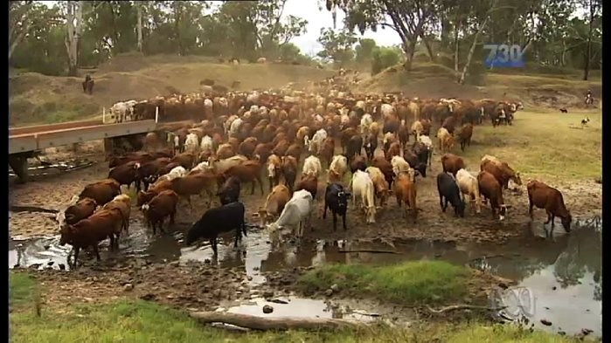
Afternoon tea will be provided, after which you are invited to stay, or just pop in any time and leave when you must for a Vigil, with music and prayers till midnight. Opportunity will be there for you to place a tea-light candle in a large bowl of water as a token of your support for our community.
The word ‘alone’ in German and English, ‘all one’, ‘allein’, in fact spell “all one”, meaning that we are never really alone, as a community we are all in this together.
Come and join us on the 9th December at 3pm. All are welcome here.
Contact: Susanna Pain 0418 637469 or Nikolai Blaskow 0428 167724

