A nourishing feast of Creativity and Fun!
27-29 April 2018.
With Rod Pattenden and Trish Watts

At St Paul’s Cathedral,
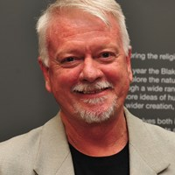
Cunninghame St, Sale

Reverend Dr Rod Pattenden, minister, artist, art historian, dancer and educational facilitator is interested in the connection between spirituality and the arts. Rod has written and lectured widely on these aspects of the arts and creativity in Australia and overseas.
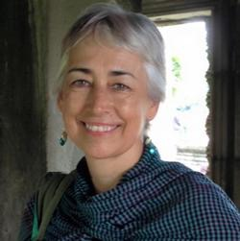
Trish Watts, singer/songwriter, educator, Voice Movement Therapy practitioner, spiritual director, and community choir director. Whether she is working with a group or individuals, her approach to life is as an adventure, evoking joy, energy, freedom, trust and connection.
songwriter, worship leader, Voice Movement Therapist.
With Susanna Pain, they celebrate over 25yrs as co-founders and leaders of InterPlay ® Australia, a community arts practice.

2pm-5pm Saturday 28 April 2018 “Play with the 5 Freedom Paths- storytelling, movement, singing, silence and connection” $25

Sunday 8 and 10am Services:
‘Sparks of Life’: …sustaining creative lives

Sunday 730pm -9pm: ‘Sanctuary’: Where heaven touches earth - uplifting & peaceful songs for inspiration, meditation & community joy. Entry by donation

To register interest, contact Susanna: 0418 637 469
Susanna.pain@gmail.com

