Who needs a Police Check?
A Police Check is not required by all members of the Ministry team within parishes/Diocesan Organisations. A Police Check however is required by the following people

Parish
- Parish Council Members
- Lay Readers
- Pastoral Assistants
- Any individual involved in youth/children’s ministry i.e. Sunday School, mainly music, youth group etc
- Any salaried Lay Administrative Staff or Youth Workers

Diocesan
- All incumbents/associates and PTO clergy
- Bishop in Council Members

The Process – Using Crimcheck

Step One:
Access the Crimcheck Application on the Diocesan Website via this link: https://www.crimcheck.org.au/check/ADG
Or follow the links through the website: Anglican Diocese of Gippsland / Resources / Safe Ministry / Crimcheck Online Application

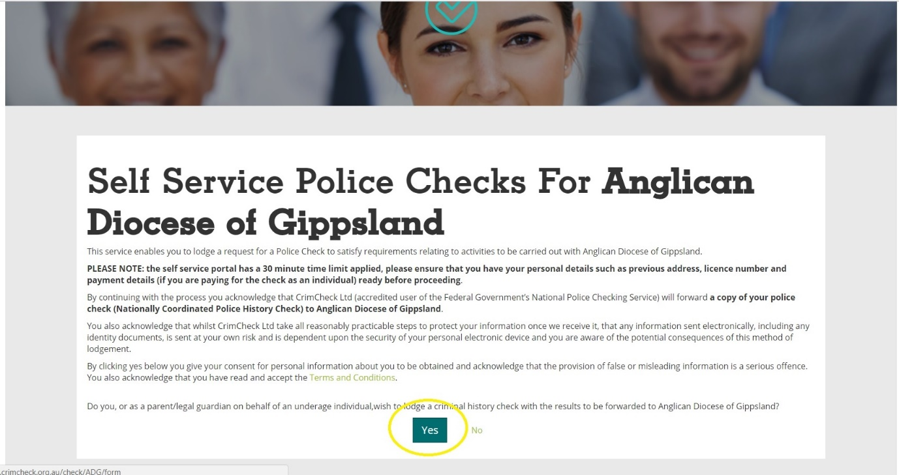
Go to https://www.crimcheck.org.au/check/ADG and select the option ‘Yes’

Step Two:

Select ‘Paid’ or volunteer as appropriate. Next enter the reason for completing the check i.e. Lay Reader, Youth Ministry, PTO etc.
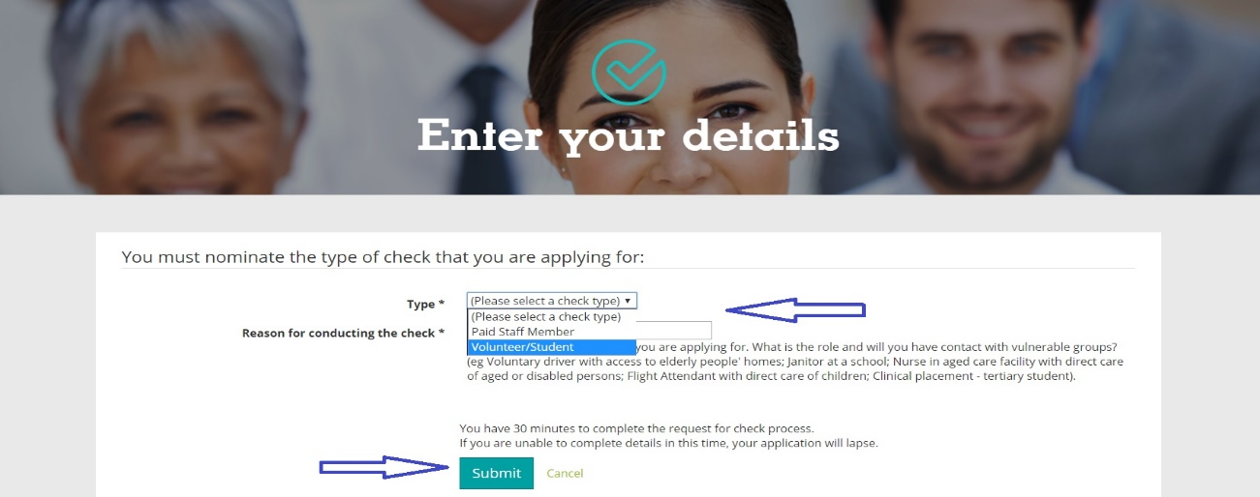
When these have been entered select ‘Submit.’
Step Three:

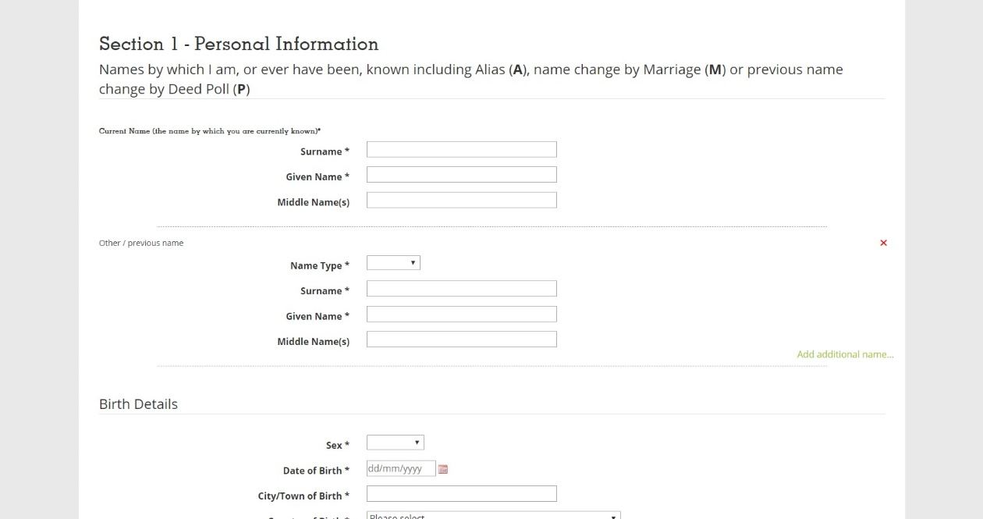
Proceed to fill in your all personal information as indicated on the page and select “Submit” when finished.

Step Four:
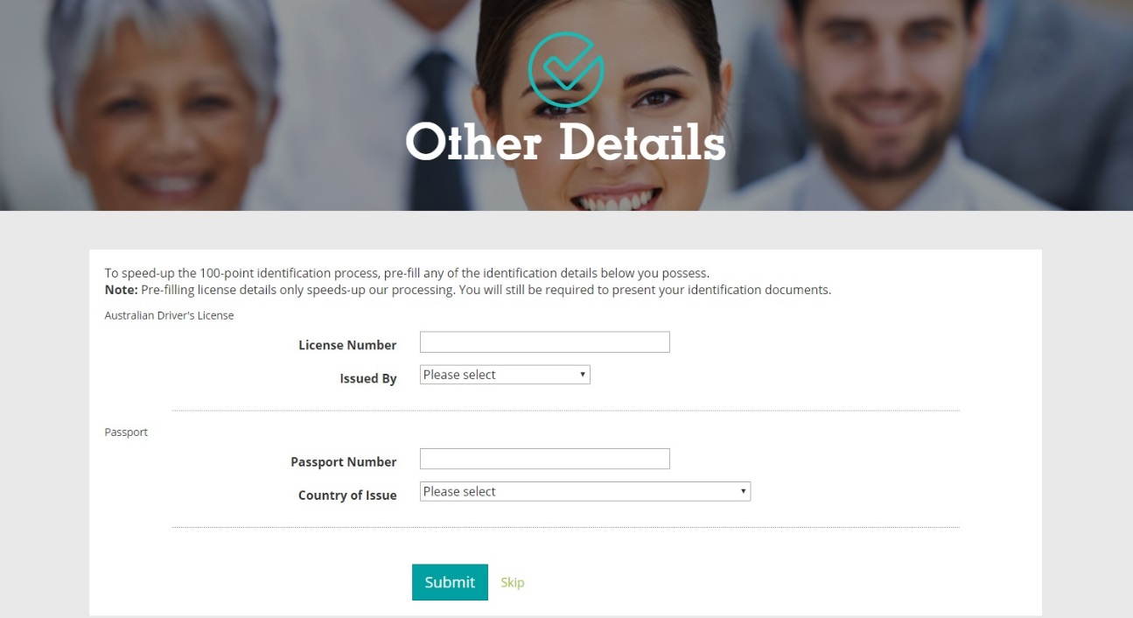
Enter in your details if you have a Drivers License and/or Passport (more ID options will be explained in Step Five) and select “Submit”

Step Five:

Your Police Check application has now been entered into the system. However, before it can be sent off, we need copies of your ID to be sent off with it. Overall, we require four forms of ID, they are however, split into different categories:
(Please note with all of these documents, we only require a legible copy, it is no longer necessary for these to be certified)

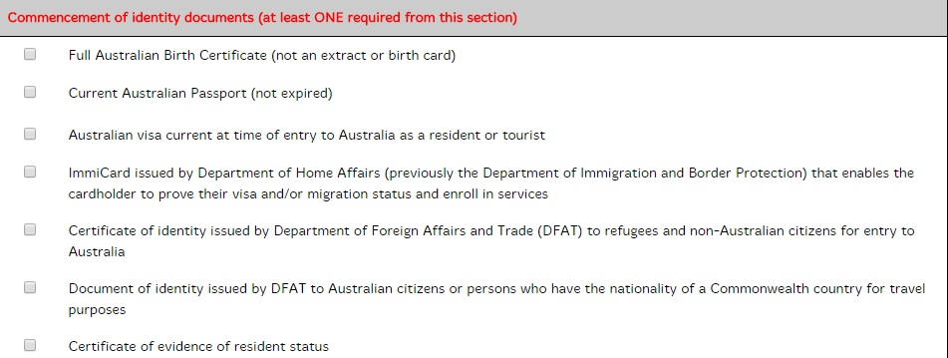
- One “commencement of identity” document as listed below:

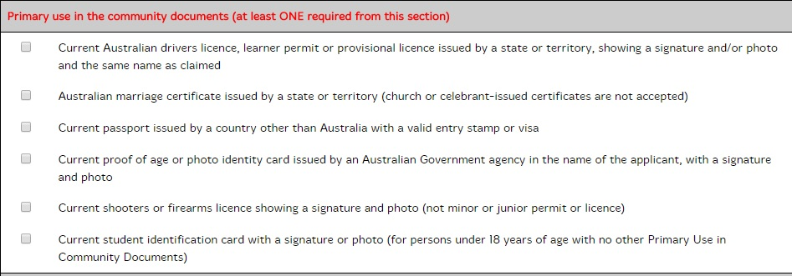
- One “primary use in the community” document as listed below:

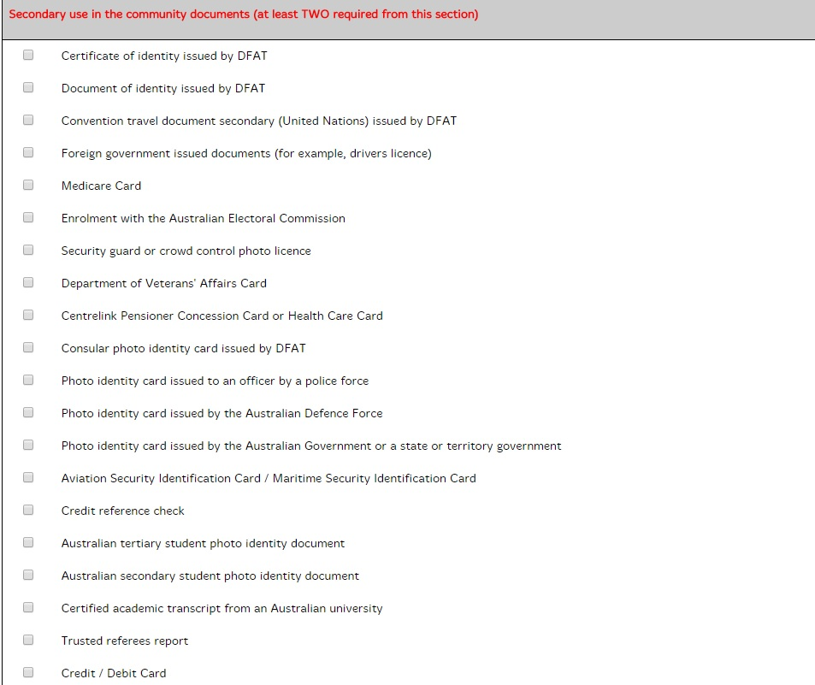
- Two “secondary use in the community” documents as listed below:

Once you have copies of these, send them to Richard Connelly (DDPS) at deputydps@yahoo.com. They MUST be sighted and your identity documents verified before the Crim check will be processed.
If you have difficulties with the. website application, please provide hard copies to the Diocesan Registry
After these have been sent, your Police Check will be processed. If you should have any queries regarding the process or what is required you can contact Richard at deputydps@yahoo.com or on 0422 109 629.

