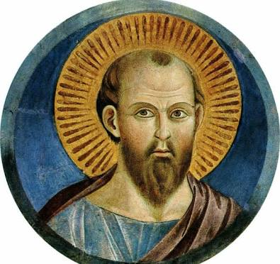

The many faces of St Paul:
Messenger, Christ follower,
the Church’s Apostle!

A lecture and workshop, by New Testament scholar
Dr Kieren Williams

Saturday 17 March 2018, 130pm - 430pm
St Paul’s Cathedral,
Delbridge Hall, Cunninghame St, Sale

Rev. Dr. Kieren Williams is an ordained minister with the United Church of Canada. As a community minister, she worked and lived in a neighbourhood that struggled with the impact of poverty and racism, and in collaboration with her neighbours, they sought to live their faith in justice and compassion through advocacy, community programming, and spiritual support. She was also a professor in New Testament at Emmanuel College which is the United Church seminary, part of the University of Toronto. For health reasons, she had to retire early, and now enjoys travelling, writing, lecturing, gardening, and supporting various social justice causes.

