**Diocesan Retreat**

**The Anglican Diocese of Gippsland**

**7-8 September 2018**

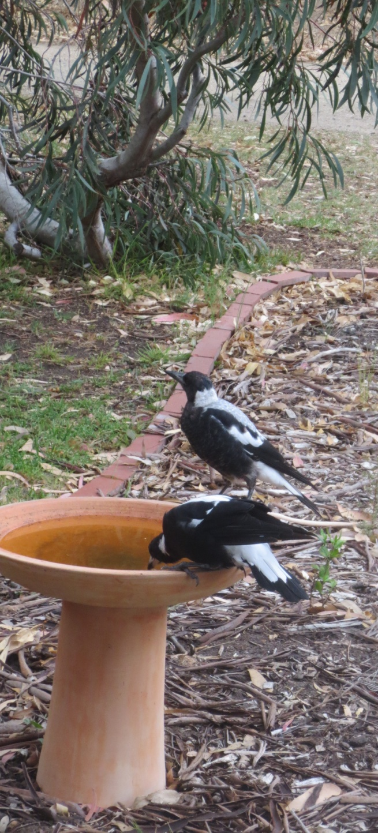

Retreat Leader

Bishop Garry Weatherill

Bishop of the Anglican Diocese of Ballarat

Come on retreat and savour the beauty and peace of The Abbey on Raymond Island.

Bishop Garry is an experienced retreat leader, greatly loved and respected among many who appreciate his teaching and spiritual wisdom.

There will be times for silence, prayer and reflection, times for learning together, times to walk, to share, to create, to be.

ALL ARE WELCOME



**1-25 First Parade, Raymond Island 3880**

**To book or further information contact The Abbey**

**Phone (03)5156 6580 Email:** [**info@theabbey.org.au**](mailto:info@theabbey.org.au)

[www.theabbey.org.au](http://www.theabbey.org.au)

**facebook: the abbey conference and accommodation centre**

5pm Fri 7 September 2018 – 3.30pm Sat 8 September 2018

Cost per person

Residential: incl. dinner Fri, breakfast & lunch Sat

twin/share accommodation: $135

single accommodation: additional $35

Non residential: incl. dinner Fri, Breakfast & Lunch Sat: $85

The retreat will be led by Dean Susanna Pain from St Paul’s Cathedral, Sale.

Susanna is an experienced retreat leader and spiritual director who loves silence, prayer, creativity, the natural environment, and seeing people grow in their relationship with God.