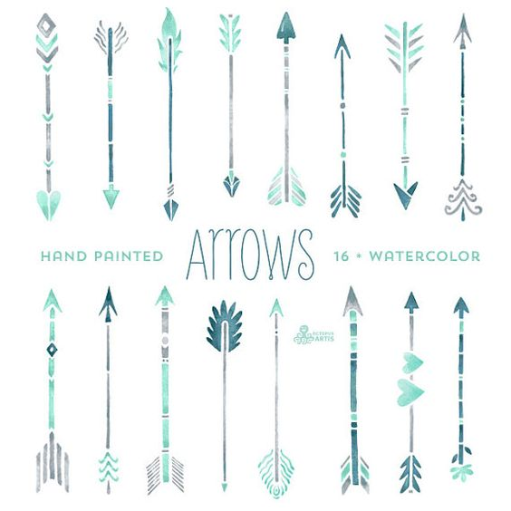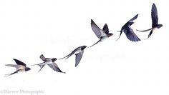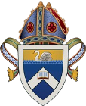

*The Abbey, Raymond Island, invites you to…*

ANGLICAN DIOCESE OF GIPPSLAND

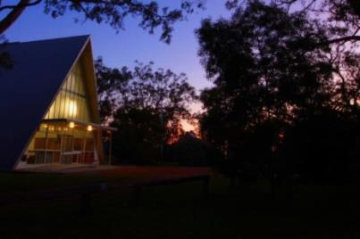

A *wholesome* weekend of gathering as one, to relax and enjoy:

Exploring The Abbey and beautiful natural environmental surrounds with   
Rev. Edie Ashley ● Spiritual nourishment and prayer ● Delicious feasting ● Live music ● Fellowship● Saturday night dinner ● Campfire sessions ● Creativity ● Early morning delights ● Event sessions and outdoor events… plus more to surprise.

Peace. Fellowship. Faith. Warmth. Natural Creation. Spirituality. Nourishment. God’s love and family.

Be our guest and feel free to invite others on the journey!

Full cost (includes accommodation and all meals): $200   
*Please contact us should cost be a challenge.

**Registration for this event closes:** 15th June 2018. *Not to be missed*!

FRIDAY 29th JUNE 2018 7.00pm to SUNDAY 1ST JULY 2018 2PM.

Contact:

[info@theabbey.org.au](mailto:info@theabbey.org.au)

(03) 51566580