ROBIN MANN Concert
730pm
Wednesday 22 November
St Paul’s Cathedral
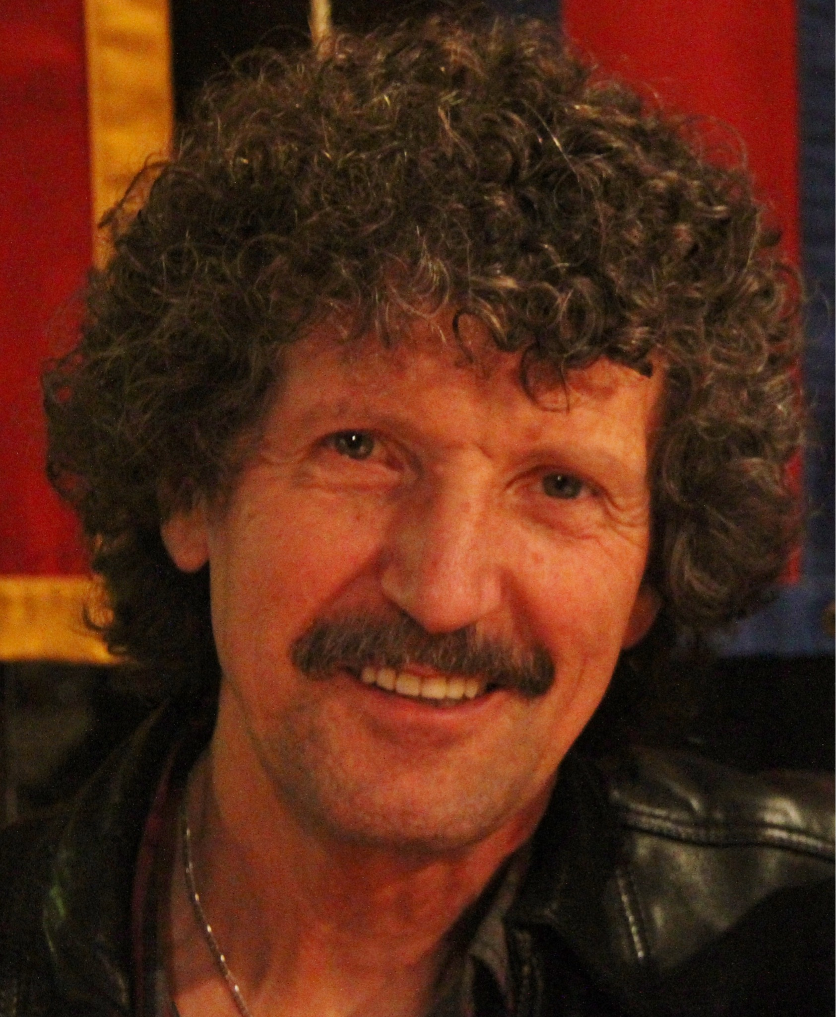
Cunninghame St, Sale

ROBIN MANN
A lifelong lover of songs, Robin Mann’s favourite musical experience is leading a keen group of any size in community song. Running a close 2nd place by a short half-head is putting together a new song for people to sing.
Robin’s been leading and writing songs for over 40 years, and he hopes to do some more yet. While he’s best known for songs like Father welcomes, Comfort comfort and May the feet of God walk with you (and more recent ones God. Version 1.0 and For you, deep stillness), he also performs some ‘non-singalong’ songs, especially for groups who didn’t get the ‘community singing’ gene.
Robin’s married to Dorothy and their long partnership has produced 3 children, numerous songs and many recordings. They’re both into a down-to-earth, commonplace sort of Christian faith. Their experience has led them to focus on God in the ordinary, and especially God-in-the-flesh bringing the wondrous new world out of a messy Roman-gallows death.
Robin’s songs focus on the ‘low way’, the way that invites others not to escape everyday reality, but to get deeper into it, He has a strong commitment to ‘plain’ Christianity, a faith that trusts in the mystery of the ‘God-man’ Jesus, and doesn’t look for miracles — apart from the numerous everyday ones already provided. He tries to include a wide variety of musical styles in his writing and collecting: ‘No music is holier than any other!’ Come and listen, and sing!

