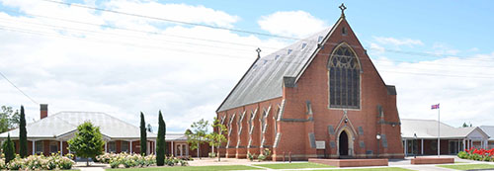

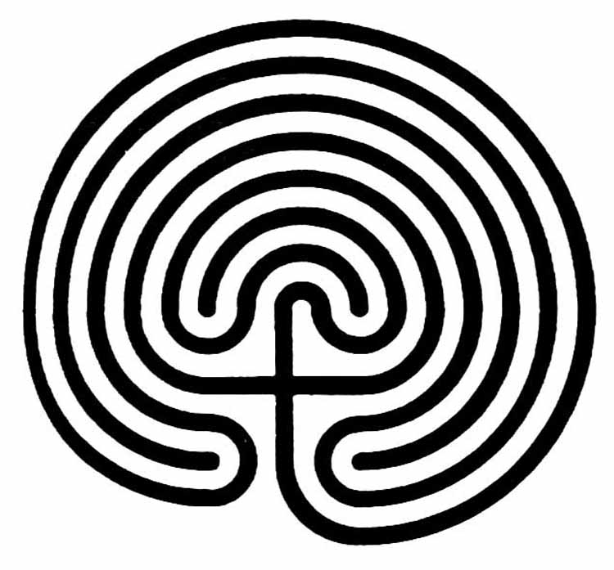
Ecospirituality Day with the Labyrinth

Delbridge Hall, Cunninghame St, Sale
25 November 2017
10 am - 4 pm
Cost: $40, concessions available.
To book: 51442020 or 0418637469
Stpaulssale@wideband.net.au

Christina Rowntree will lead a retreat day in and around Sale focussing on our embodied connection to the Earth. Both labyrinth and pilgrimage walking are spiritual practices in many faith and no-faith traditions. These walks will invite you to form a stronger connection with the Earth.

We will walk the labyrinth in the morning, and outdoors in the afternoon, noticing the turning from inward personal focus and moving to an outward connection with the body of the Earth. We will walk a pilgrim path, seeking wisdom on the journey, forming insights and intentions for a practice that will sustain us through the coming season. There will be time for personal reflection and journaling, and some educational input about the history and uses of the labyrinth.

Bring your own stories and memories, and something that represents your own connection with your place. Perhaps something from your garden, a painting, a photograph you’ve taken, or something you’ve made with natural materials.

Christina Rowntree is a community artist, storyteller, and arts facilitator with a particular focus on the arts and spirituality. With community group, A GrandStand for the Environment, she devised and ran TableTalk, a process for engaging people in conversation about climate change by evoking memory, heart connection and spirituality.

Christina has walked a pilgrimage around St. Bride’s Bay in Wales, where sacred story and song supported the walk. In Victoria, she has led a group walk, telling stories of the shipwreck coast on the Great Southern Walk. She is an accredited labyrinth facilitator through Veriditas, the global labyrinth movement.

