A Celtic
Quiet Day

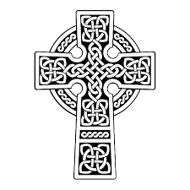
Led by:

Carol O’Connor
Poet, teacher and book seller

and

Cath Connelly
Spiritual director and harpist

St Patrick’s Day
Saturday 17th March, 2018
St Thomas’ Anglican Church
16 A’Beckett Rd, Bunyip
9.30am – 3.30 pm

What to bring: Lunch to share.
Tea/coffee/water & Morning Tea provided.
Cost: $10.00

RSVP and for further details, contact:
Bunyip parish office: anglicanbunyip@dcsi.net.au or
Jane Macqueen: jemacqueen@gmail.com

A Ministry of the Parish of Bunyip

and

The Anam Cara Community

